Before Data augmentation and regularization (dropping neurons)

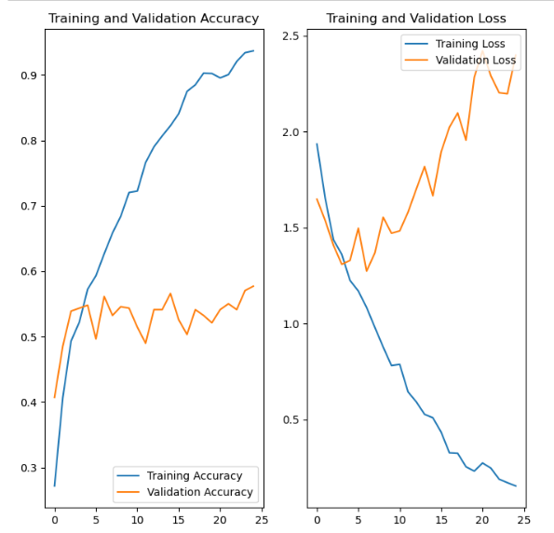

After using Augmentation and regularization

